CSE 574

HW 2

Due Friday September 14 at 5pm

*Please submit on Blackboard. Show work for full credit. The programming assignment portion of the HW should be submitted as a separate file. See the class policies for late HW assignments as we will strictly enforce them.*

Name:

ASU ID:

**1. Uninformed Search.** Iterative lengthening search is an iterative analog of uniform cost search. The idea is to use increasing limits on path cost. If a node is generated whose path cost exceeds the current limit, it is immediately discarded. For each new iteration, the limit is set to the lowest path cost of any node discarded in the previous iteration.

a. Show that this algorithm is optimal for general path costs.

b. Consider a uniform tree with branching factor b, solution depth d, and unit step costs.

How many iterations will iterative lengthening require? (please show your work)

c. Now consider step costs drawn from the continuous range [ε,1], where 0 < ε < 1. How

many iterations are required in the worst case?

**2.** **Informed Search.**

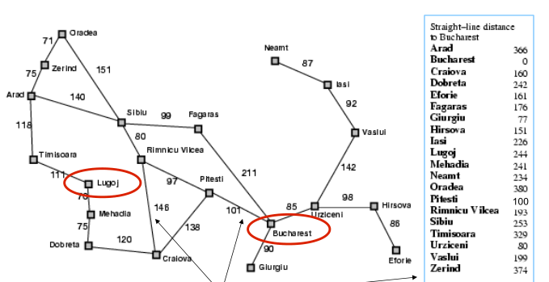

Apply the A* search on this graph to reach Bucharest from Lugoj using the straight-line distance heuristic function. Show the sequences of nodes which are considered by the algorithm. Show the f,g,and h for each node.

3. **Properties of a heuristic.** With the numbers on the arcs as ground truth costs and the h values as heuristics in the below diagram, is h(n) admissible? Is h(n) consistent? Explicitly use the definitions of admissible and consistency in your argument. Show that A* using GRAPH-SEARCH on the state space shown below returns a suboptimal solution. 

4. **Constraint Satisfaction Problem.**

In a zoo several animals were brought and four enclosures were built. Because there

are more animals than enclosures, some animals have to be in the same enclosures as

others. However, the animals are very picky about who they live with. Can you plan

where each animal goes?



The animals chosen are a LION, ANTELOPE, HYENA, EVIL LION, HORNBILL,

MEERKAT, and BOAR. They have given you the plans of the zoo layout.

Each numbered area is a zoo enclosure. Multiple animals can go into the same

enclosure, and not all enclosures have to be filled.

Each animal has restrictions about where it can be placed.

1. The LION and the EVIL LION hate each other, and do not want to be in the

same enclosure.

2. The MEERKAT and BOAR are best friends, and have to be in the same

enclosure.

3. The HYENA smells bad. Only the EVIL LION will share his enclosure.

4. The EVIL LION wants to eat the MEERKAT, BOAR, and HORNBILL.

5. The LION and the EVIL LION want to eat the ANTELOPE so badly that the

ANTELOPE cannot be in either the same enclosure or in an enclosure adjacent to the LION or EVIL LION.

7. The LION annoys the HORNBILL, so the HORNBILL doesn't want to be in the

LION's enclosure.

8. The LION is king, so he wants to be in enclosure 1.

Using the reduced domains provided below, find one solution using depth first search

with forward checking and propagation through domains reduced by any number

of values (propagation through reduced domains). Show your work by filling out the

domain worksheet on this page and drawing the search tree on the next page. Break

ties in numerical order (1,2,3,4).



Fill out this worksheet as you draw your search tree. There may be more rows than you

need. Every time you assign a variable or remove a variable from the propagation queue,

fill out a new row in the table. (The same variable might appear in more than one row, especially if you have to backtrack.) In that row, indicate which variable you assigned or dequeued; write its assigned value if it has one (e.g. X=x), otherwise just write its name (X). In the second column, list the values that were just eliminated from neighboring variables as a result. If no values were just eliminated, write NONE instead. If your search has to backtrack after assigning or de-queuing a variable: first, finish listing all values eliminated from neighboring variables in the current row. Next, check the backtrack box in that row. Then, continue with the next assignment in the following row as usual. At some point, you might add several variables to your propagation queue at once. Break ties by adding variables to your propagation queue in alphabetical order.





5. **Alpha-Beta Pruning.** Given the following search tree, apply the alpha-beta pruning algorithm to it and show the search tree that would be built by this algorithm. Make sure that you show where the alpha and beta cuts are applied and which parts of the search tree are pruned as a result.



**6. Adversarial Search.** A two-player game is described below.

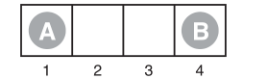

Player A will move first. Each player can only move to empty slot in either direction. If the opponent is your direct neighbor, you can jump over them if there is any space. For example, if B is on 3, A is on 1, A could jump over B to 4. The game would end when one player reaches the opposite end of the board. If A reaches 4 first, the terminal value of the game is +1, if B reaches 1 first, the terminal value of the game is -1.

a. Draw the complete game tree, using the following conventions:

* Write each state as (sA, sB), where sA and sB denote the token locations.
* Put each terminal state in a square box and write its game value in a circle.
* Put loop states (states that already appear on the path to the root) in double square

boxes. Since their value is unclear, annotate each with a “?” in a circle.

b. Now mark each node with its backed-up minimax value (also in a circle). Explain how

you handled the “?” values and why.

c. Explain why the standard minimax algorithm would fail on this game tree and briefly

sketch how you might fix it, drawing on your answer to (b). Does your modified algorithm

give optimal decisions for all games with loops?

d. This 4-square game can be generalized to n squares for any n > 2. Prove that A wins

if n is even and loses if n is odd.

7. **Programming assignment.**

**Tic-tac-toe**

Tic-tac-toe is a pencil-and-paper game for two players, X (ascii value 88) and O (ascii value 79), who take turns marking the spaces in a 3×3 grid. The player who succeeds in placing three respective marks in a horizontal, vertical, or diagonal row wins the game. Empty space is represented by _ (ascii value 95), and the X player goes first.

Here is an example game won by the first player, X:

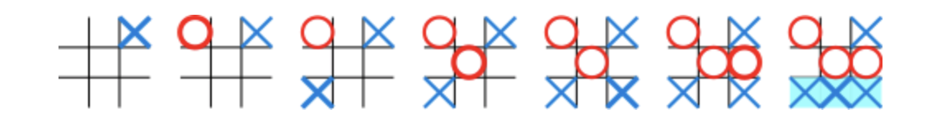

The function alpha_beta_minimax() takes in a state of the board. ***You should complete this function*** to print 2 space separated integers *r* and *c* which denote the row and column that will be marked in your next move. The top left position is denoted by (0,0).

Note: the state is a class that has the board (2d array which captures values in 3X3 grid), current player, whether its max-player or not, next move.

Please implement the alpha_beta_minimax() using the included helper functions in alpha_beta.py included as a file with this assignment.

**How does it work?**

Your code is run alternately with the opponent bot for every move.

**Example input:**

X

___

___

_XO

**Example output:**

1 0

Explanation

Next move is

___

X__

_XO